2015 Summer Term Alumni Research Scholars Research Proposal: Harnessing Interference in Wireless Networks: Building

**1. Introduction**

Taking Signals and Systems (EC 401), Digital Signal Processing (EC416), and Probability Theory (EC381), I have been fascinated by how the complicated mathematics and physics knowledge I have been building up since high school years actually being applied to the real world. By participating Professor Bobak Nazer’s research on Wireless Communication, I will have not only the opportunity to have hand-on experience in the field of signal processing, but also attempt to contribute to making innovative solutions for the technical challenges that the field of Wireless Communication is currently facing by utilizing my solid background on programming, mathematics, and signal processing.

**2. Background & Literature Review**

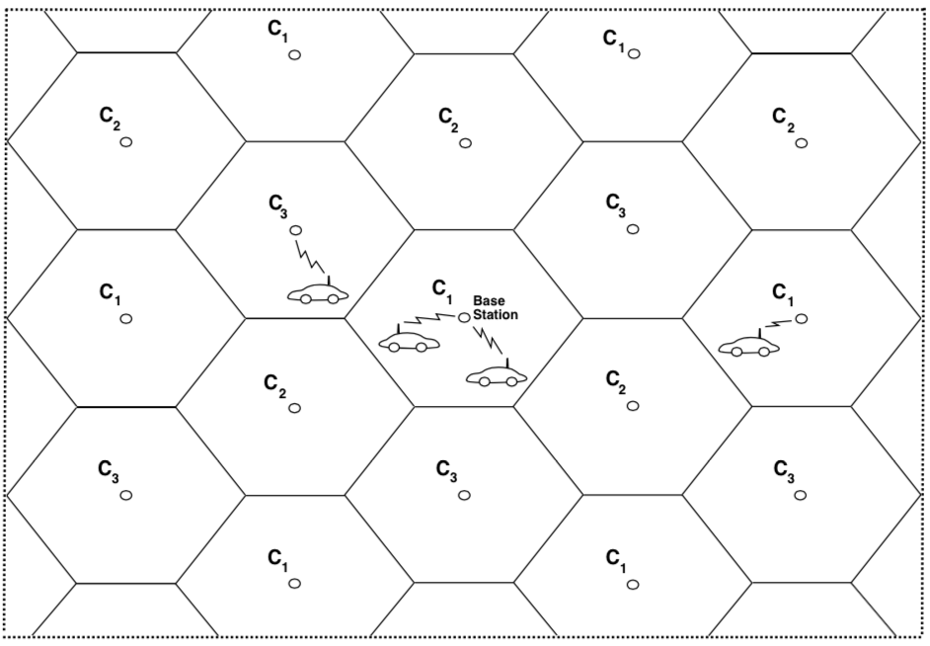Wireless Communication is the most rapidly developing in the industry of communication due to the exponential growth of demand for exchange of information. Millions of moving users are sending and receiving information simultaneously through invisible waves in free space, and reducing interferences between the information, called fading, had been the biggest task[3] . Over the decades of research, current wireless communication operates under well-developed system, which manipulates the fact that the signal power falls off with distance to reuse the same frequency spectrum at spatially separated locations [1]*.* The coverage area for the system is divided into multiple cells, and each cell is control by its base station. The same channel is used in multiple cells concurrently with certain distance between them so that the channel cannot be overlapped (Figure 1 [1]). The methodology to eliminate the interference within the same cell is called Multiple Access Technique that includes Frequency Division Multiple Access (FDMA), Time Division Multiple Access (TDMA) [2]. The methodology to eliminate the interference with neighboring cells is called Interference Management that includes Narrowband and Wideband network architecture [2].

Figure 1. Cellular System

**3. Research and Methodology**

Although current operation of Wireless Communication has been developed significantly, the industry is now facing more challenging problem as the demand for wireless network system is increasing exponentially: scarcity of radio spectrum [3]. Since most of the signals are absorbed in the air, the selection of the frequency is very limited (Figure 2 [5]). As a result, the frequency spectrum is strictly regulated by government [5]. Licensing partial spectrum from given frequency band is very expensive; U.S. companies spend over nine billion dollars for the second generation cellular licenses [1]. Technologies today, such as smart phones and HDTV, have occurred the rapid increment of the demand in wireless service [3], and the as users demand for the service, the data rate is significantly decrease. The goal of this research is to investigate the potential solutions for the technical limitation. The research will begin prototyping and simulating the techniques on Wireless Open-Access Research Platform (WARP) [4]. WARP v2 board, which is available at Boston University, can be programmed by MATLAB and C. Unlike other Board Development, WARP Board can be implemented with high-level languages, and this can make the prototyping of the techniques and simulation much easier and faster.

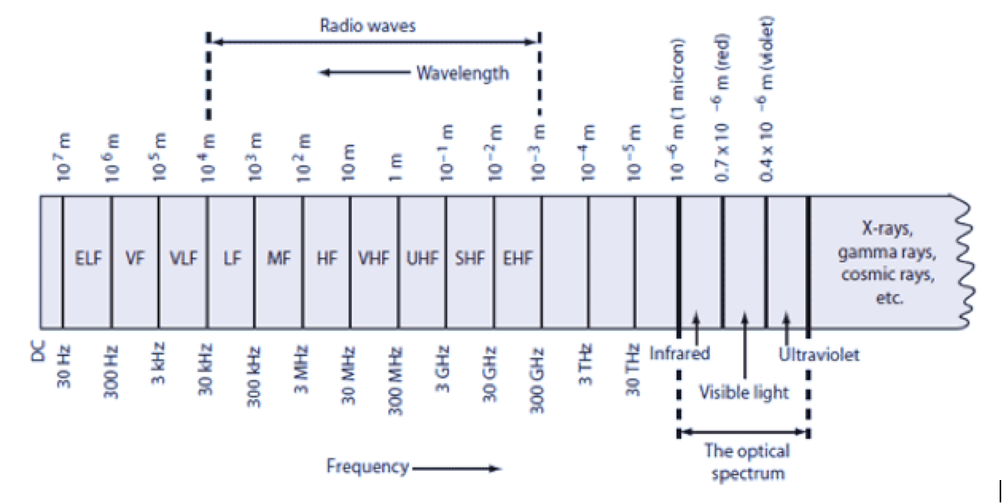

Figure 2. Electromagnetic Frequency Spectrum

**4. Preparation**

I am currently taking Digital Signal Processing that requires me to simulate signals on MATLAB, so by the end of this semester, I will also be familiar with signal simulation, which is very important task for this research. I also have an experience with developing FPGA Board using Verilog, so I understand how programming and physical machine interact each other. Under Professor Nazer’s guidance, I am exploring materials in Wireless Communication as a preparation for this research over the summer.

**5. Conclusion**

Wireless Communication is the field that has huge potential, and it must grow for the next generation. One of the aspects that I am fascinated about engineering is that numerous trials and failures are the best way to learn rather than memorization of intangible concepts and equations. Although I have a solid background in math and physics, I had always wondered where I could contribute my knowledge. Learning Signal Processing enlightened the idea for my career, and this research on Wireless Communication will allow me to take a big step.

**References**

[1] Goldsmith, Andrea. *Wireless Communications*. Cambridge University Press. 2015.

[2] Nazer, Bobak. “Cellular Systems.” Lecture, Wireless Communication from Boston University, Boston, MA, 2014.

[3] “The Issues in Wireless Communications.” Accessed March 11, 2015. <http://www.wirelesscommunication.nl/reference/chaptr02/issues.htm>.

[4] *WARP Project* (website). <http://warpproject.org>

[5] Frenzel, Lou. “Understanding Solutions For the Crowded Electromagnetic Frequency Spectrum.” *Electronic Design.* Accessed March 11, 2015. http://electronicdesign.com/communications/understanding-solutions-crowded-electromagnetic-frequency-spectrum#1